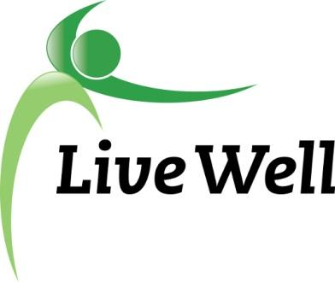
AGENDA

Healthy Food for All Work Group
Virtual Meeting via Google Hangouts: meet.google.com/khm-drvc-owq

2:00pm – 3:30pm, Thursday, June 24th.

Agenda items | Notes | Action Items
Introductions | - Welcome everyone! Introductions, Accomplishments, and Ice Breaker: What is your favorite or go-to summer meal? | Jessica Cooney (JF), Ryan Bowersox (JF), Michaela Cantrell (JF), Cierra Smallwood (K-State), Kate LaRosh (Harvesters), Mary Jane Hoffer (Lecompton United Methodist), Michele Dillon (JAAA), Nancy O’Connor, Susan Farley (K-State), Elizabeth Billings (UHC), Laura MCCulloch (health dept), Allison Koonce (LMH), Frankie Haynes (LPL), Marty Scott (LiveWell), Valorie Carson (?), Norm White (DCF)
Announcements | - Last meeting of this term! Big thank you to Ryan for all her hard work!  - Does this meeting time still work for everyone?  - Updates to Community Checkbox - List em’ off!  - MPO/Just Food Maps  - Updates to Rx Pad  - Additional Pathways Updates | - 1)Meeting Time- stays the same for now  - 2)Go through action steps  - pantry meeting Aug 12th, 10:30-12pm  - low access transit map w/Laura  - TripleUp days- dates made, not promoted yet, July & August, maybe another day, Lawrence Market & Cottin’s  - FuelGood pantries put on hold for COVID, starting again in Fall 2021  - Document Purposeful Plate stuff later when it comes up, pending approval from Restaurant Association & pilot with restaurants  - Seniors & SNAP- English & Spanish  - CHAMPPS- few sites left, trying to get one in Baldwin, plenty in Topeka & Jefferson county  - Farmers Market Checks available, 60+ & Low Income, Send announcement to Just Food CSFP people for these  - 3)Maps - Just Food numbers, delivery, transportation  - 4)RX Pad - incentive - free unlimited produce at visit at JF, food resource guide QR code,  - 5) Updates  - Cruising Cupboard July spots with KDHE, LDCPH, & on 23rd  - Work group leadership changes - Chair Elect  - Potential In-person meetings? Yes/No?  - Poll with potential time change and in-person questions  - LiveWell website revamp- questions about its uses, brainstorm and questions on next month’s agenda, community spot for resources, will be helpful if it is continuously updated & maintained, user-friendly & functionality
Sharing of Resources/ Community Needs | - Covid Resources: To see if you have correctly filled out the Vaccine Interest Form, you can search for the record here: dgcoks.org/vaccineinterestformsearch. This list of names will be updated at 11 a.m. weekdays (Monday-Friday). If no record is found, please fill out the form again. Here's the link: dgcoks.org/vaccineinterestform.
HFFA Leadership Transition | - Chair Elect! Apply for it!
On-Going Projects
Adjourned | - TBD

